**PES University, Bangalore**

(Established under Karnataka Act No. 16 of 2013)

**Department of Computer Science and Engineering**

**UE21CS352A : OBJECT ORIENTED ANALYSIS AND DESIGN USING JAVA**

**Mini Project**

**Title – Online Coding Evaluation Platform**

**State Diagram & Activity Diagram**

**NAME :-** Monisha S

**SRN :-** PES2UG22CS809

**CLASS :-** 6th Sem ‘A’ Sec

**TEAM-ID :-** A10

**State Diagram**

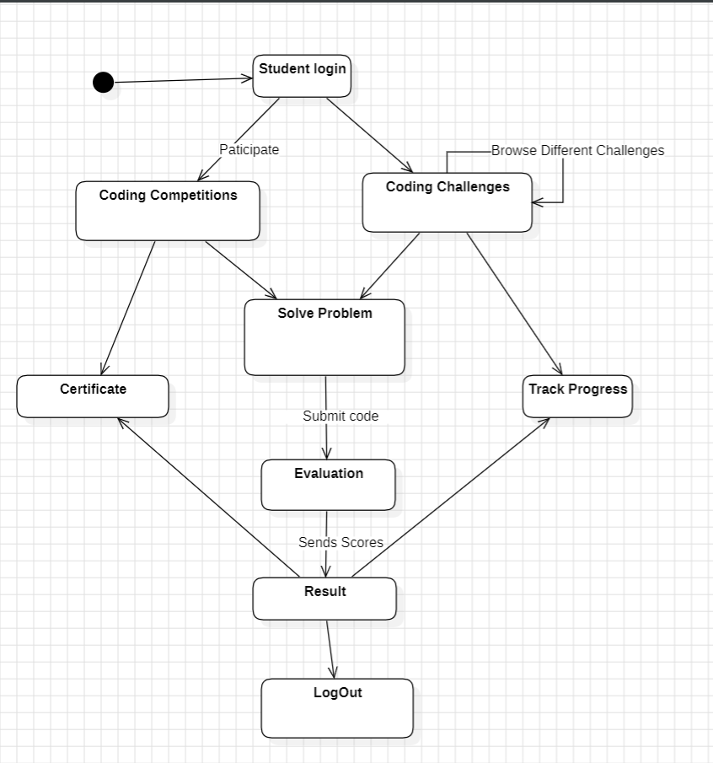

**Activity Diagram**

